**SOFTWARE REQUIREMENT SPECIFICATION**

(APPRAIL/2021/001)

**for**

**ORANGEFLY (Phase 1)**

APPRAIL ORANGEFLY

_____________________ __________________

(Name & Signature) (Name & Signature)

Prepared By:

**APPRAIL Team**

**Document Revision History**

|  |  |  |  |  |  |
| --- | --- | --- | --- | --- | --- |
| Rev No | Rev Date | Updated By | Reviewed by | Approved by | Change Log |
| 0 | 9/4/2021 | Suraj Rajan |  |  | Initial Version |

**Table of Contents**

**1. Introduction 3**

**1.1. Scope 4**

**1.2. Definitions, acronyms and abbreviations 4**

**1.3. References 4**

**1.4. Overview 5**

**2. Overall descriptions 5**

**2.1. Process Flow 5**

**2.4. Operating Environment 7**

**2.5. Software Architecture 7**

**3. Specific Requirements 8**

**3.1 Hardware Requirements 8**

**3.2 Software Requirements 8**

**3.3 License Requirements 8**

**4. Application Navigation 9**

**4.1 Application Icon 9**

**4.2. Launch / Splash Screen 10**

**4.3. Home Page 11**

**4.4. Photos 12**

**4.5. Login Page 13**

**4.6. Upload Images 14**

**4.7. Account 15**

**4.8. Cart 16**

**5. Behavior Requirements 17**

**5.1. Data Flow Diagram 17**

**5.2. Use Case View 18**

**Table of Figures**

**Figure 1 : Process Flow 8**

**Figure 2: Software Architecture 9**

**Figure 3: Application Icon 11**

**Figure 4: Launch/Splash Screen 12**

**Figure 5: Home Page 13**

**Figure 6: Photos 14**

**Figure 7: Login Page 15**

**Figure 8: Upload Images 16**

**Figure 9: Account 17**

**Figure 10: Cart 18**

# Introduction

The Software Requirement Specification specifies the requirements for the Orangefly Mobile Application, which is created for the end users to have a memorable picture of their interest which can be printed in the form of Photo prints, Photo books, Albums, Photo cards, Frames, etc.

The mobile application is used only on Android platform. The application needs a stable internet connection where the purchase can be done via online. The order purchase can be done only on India, Chennai location where the delivery is applicable.

## Scope

AppRail in its scope of work will design and develop the Mobile Application which is used on the Android Platform. The base version of the OS and the minimal hardware requirements will be furnished in detail on the upcoming revised proposals when the development is implemented.

The development of this application is split into two stages.

1. First Application is created on Android Platform where the customers can access the product and place the order based on their requirement.
2. The Second is a Web Application where the vendor will access the portal via web where the order statements and the admin activities such as frame uploading, offers, reports can be accomplished.

## 1.2. Definitions, acronyms and abbreviations

SRS - Software Requirement Specification

APK – Android Package

AWS – Amazon Web Service

SNS - Simple Notification Service

SMTP – Simple Mail Transfer Protocol

## 1.3. References

Commercial Proposal: Discussions with Mr. Mari Muthu for Orangefly Application thru Call by Arulmani.

## 1.4. Overview

This system provides an easy solution for the end users to have memorable pictures/photos which can be printed in the form of Photo prints, Photo books, Albums, Photo cards, Frames without physically going to the shop/studio. This proposed system can be used by any users and it does not require any educational level, experience or technical expertise in the computer field.

# 2. Overall descriptions

The Orangefly mobile application can be used by the customers where they can print the pictures and get delivered to their destination. The application required stable internet connection to place the order and enable the features from Orange fly.

When opening the application, the home page appears. The home page has 5 navigation options

* Store
* Photos
* Upload
* Account
* Cart

Once the items are added in cart the next step will be navigating to Payment Gateway. The Customers can choose their desired mode of payment. After successful payment got completed the order will be received to the customer by 24 hours.

** The Application will be available on Google Play store. Only the users from India can access and use this application.

## 2.1. Constraints

When using the Orangefly application the users must ensure that they are following the below guideline to ensure the efficiency is maintained

* Must have an Android mobile to use the Application
* Stable Internet connection with mobile network/wifi needed.
* Android base version must be 8.1 and above
* Minimal storage of 20 MB is required to install application.

## 2.2. Process Flow

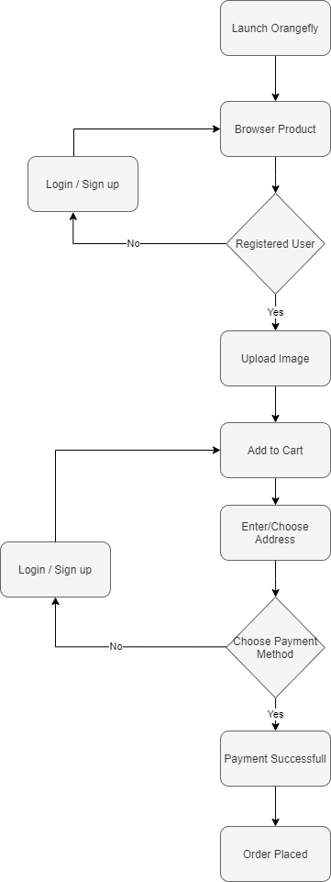

Figure 1 : Process Flow

## 2.3. Operating Environment

An Android based Smartphone with a full internet connection is required for the Mobile Application. The APK file will also be uploaded on the Google playstore by Apprail Team where the customers can navigate to playstore and download the application.

The Android version which is recommended for operating this application is Android Oreo 8.1. This is the minimal version of the operation system where Apprail will recommend the customers to use the application

## 2.4. Software Architecture

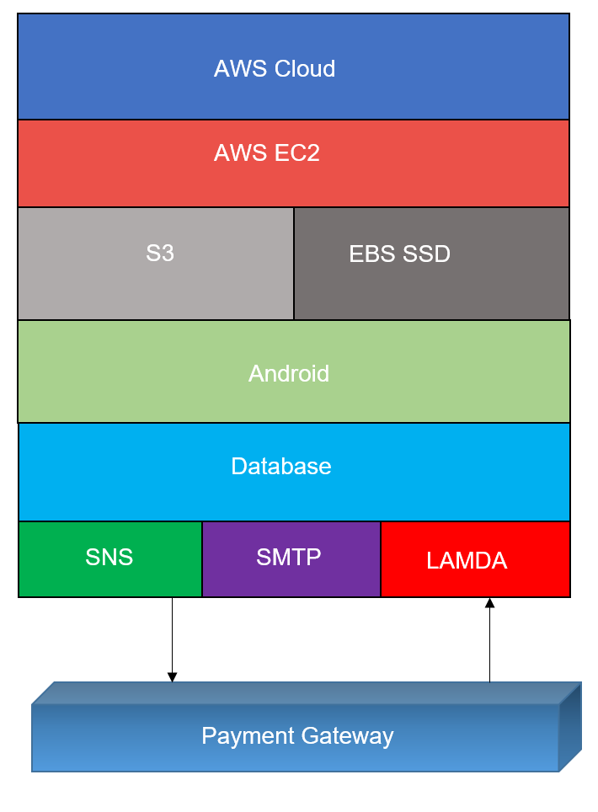 The General Architecture for the Orangefly application will be based on the below diagram:

Figure 2: Software Architecture

# Specific Requirements



## Hardware Requirements

1. The recommended system requirements to run to develop this application

* 6 Core processor / 3.4 GHz / 18MB Cache
* 8 GB RAM / 120 GB HDD / 64bit Windows

1. The application will be hosted on the Cloud platform AWS where the scalability and performance of the application won’t be impacted.
2. When Purchasing the AWS platform, the predefined set of services / requirements need to be added

* S3 Storage
* API Gateway
* Lambda
* Mongo DB / SQL / PSQL
* SNS
* SMTP

## Software Requirements

The application will be hosted and working on the AWS cloud platform. The software requirements and the minimal recommended version for this application is furnished below:

***Operation System:*** Standard Windows Server

***Cloud Vendor***: AWS

***Database:*** Mongo DB v4.0 and above / Microsoft SQL server 2017 and above

***Software:*** Python v3.7 and above | Android Studio

## License Requirements

For developing the application, the recommended software which we are using need to be purchased as a part of licensing. The list of licensed software will be furnished below:

***Operating System*:** Windows

***Database:*** Microsoft SQL Server

# Application Navigation

The Orange fly application will be downloaded from the Google Playstore once the product is launched. The corresponding pages will be having a pictorial representation as how the product will be visualized and how this can be navigated.

The product outline will be picturized and based on your requirement the final product will be released after having a brief communication.

**Note\*\***

**All Pictures shown are for illustration purpose only. Actual product may vary due to product enhancement.**

### 4.1 Application Icon

The orange fly application will be installed on the Android platform. The user need to select the below icon and navigate through the application.



Figure 3: Application Icon

### 4.2. Launch / Splash Screen

 When the user is opening the Application the first visual representation of the Orangefly will be mentioned as logo and Name as picturized below:

Figure 4: Launch/Splash Screen

The above image will be visualized initially as a single image only. No animation is created so far on the development. On lateral phase based on the requirement this can be altered.

### 4.3. Home Page

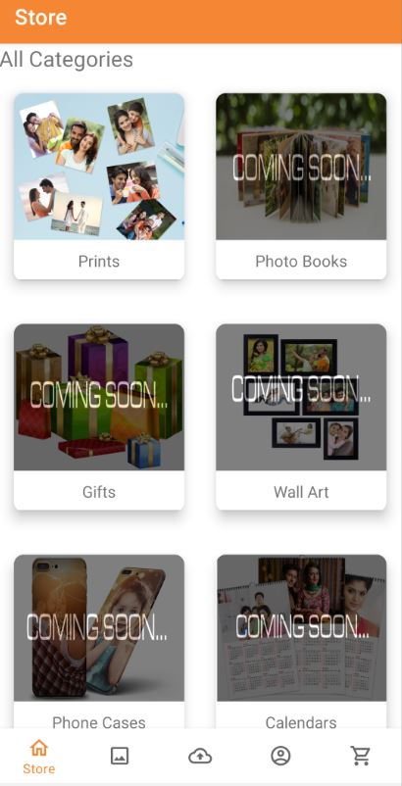The home page will be having the overall view of the product. The initial phase of the product launch will have the option to print the photos when the customers upload their images. The upcoming features of the Orangefly application will be mentioned as “Coming Soon” feature. This will tempt the customers to have a more interest on our application.

b.

a.

g.

f.

e.

d.

c.

Figure 5: Home Page

1. Print option for the customers to choose printing the images
2. The coming soon features of Orangefly application
3. Home page navigation
4. Photos to be chosen when the customers have uploaded
5. Uploading the images on Orangefly
6. Account details of the Customers can be viewed
7. The cart will have the options to view the product out to purchase.

### 4.4. Photos

Once the user signed in and uploaded the images, user will have the visibility on the photos that they have uploaded. Using the Photos page, they can view the overall pictures that customer have uploaded on their account.

Figure 6: Photos

### 4.5. Login Page

When a user is using the application for first time and they are opting to user the Application the customer will be opted to sign in to the application.

If the user is an existing customer and forgot their password, they will have the option for forgot password where the password reset option will be taking place.

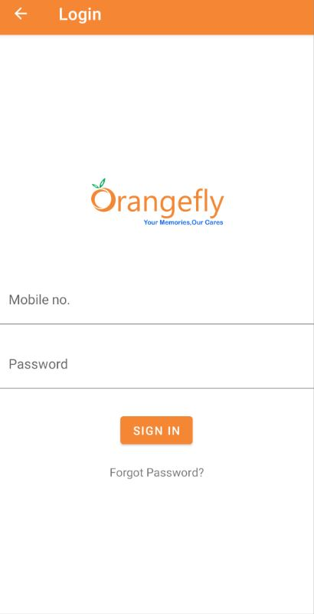

Figure 7: Login Page

### 4.6. Upload Images

The user is willing to upload their images on the Orange fly application. They can opt this feature and upload their images and retrieve anytime based on their usage. This will allow the application to use this feature to print the images.

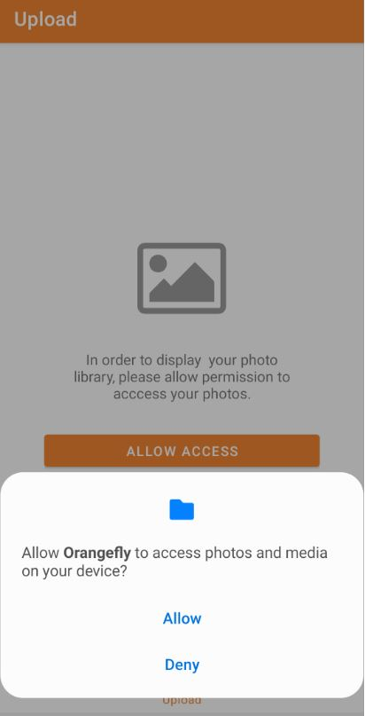 For using this feature first time the user need to give permission to read the phone memory storage, else this option can’t be opted by the customer

Figure 8: Upload Images

### 4.7. Account

The successful signed in users will have this option enabled where their account details will be visible. The Various options will be specified for the customer centric experience.

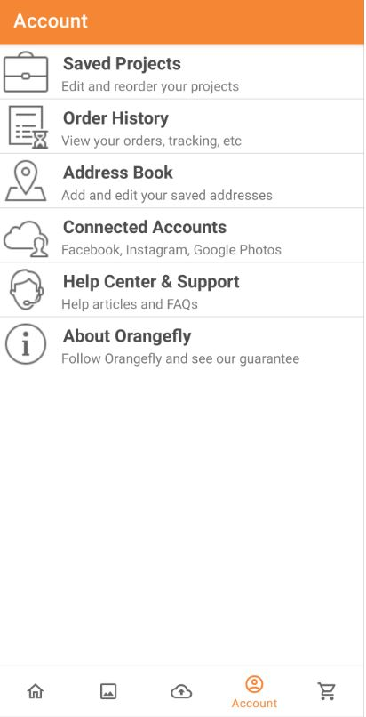

a.

b.

c.

d.

e.

f.

Figure 9: Account

1. Existing Saved products can be reviewed and proceed to print out.
2. Previous order history and order status can be viewed.
3. The personal information address can be reviewed from this option.
4. Social media integration can be enabled using this option
5. For Customer support this option will be enabled
6. The Orangefly application and the details will be specified.

### 4.8. Cart

The items on the cart can be viewed. If the customer order is pending, that option can be viewed from the cart option.

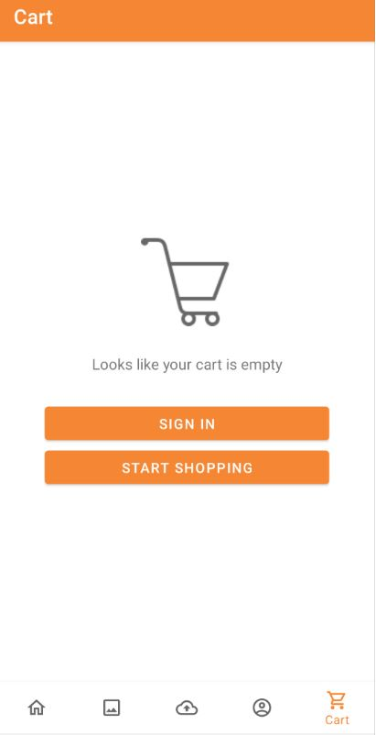The un registered users need to sign in to view the items in cart else, the user will have the option to sign in to their account.

Figure 10: Cart

## Behavior Requirements

### 5.1. Data Flow Diagram

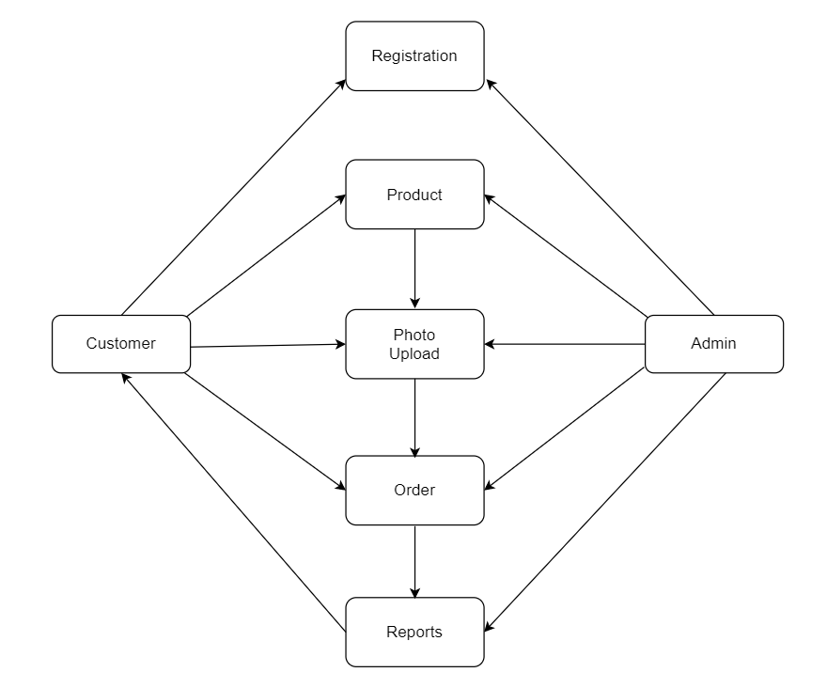

### 5.2. Use Case View

